EXPERIMENT 7
CODING
clc;
clear;
close all;

% EXPERIMENT 7
% Design and Analysis of FIR Filters Using
% Parks-McClellan and Frequency-Sampling Techniques

%% 1. INPUT PARAMETERS

Fs = 1000; % Sampling frequency (Hz)
Fp = 100; % Passband edge (Hz)
Fst = 150; % Stopband edge (Hz)
N = 40; % Filter order

% Normalized frequencies
F = [0 Fp Fst Fs/2]/(Fs/2);

% Desired response
A = [1 1 0 0];

%% 2. PARKS-MCCLELLAN METHOD

% Design FIR filter using equiripple method
b_pm = firpm(N, F, A);

disp('====================================');
disp('PARKS-MCCLELLAN FILTER COEFFICIENTS');
disp('====================================');

disp(b_pm);

%% 3. FREQUENCY-SAMPLING METHOD

% Define desired frequency response samples
F_samples = [0 Fp Fst Fs/2]/(Fs/2);
A_samples = [1 1 0 0];

% Design FIR filter using frequency sampling
b_fs = fir2(N, F_samples, A_samples);

disp('====================================');
disp('FREQUENCY-SAMPLING FILTER COEFFICIENTS');
disp('====================================');

disp(b_fs);

%% 4. FREQUENCY RESPONSE

[H_pm, f] = freqz(b_pm, 1, 2048, Fs);
H_fs = freqz(b_fs, 1, 2048, Fs);

%% 5. MAGNITUDE RESPONSE COMPARISON

figure('Color','w');

plot(f, 20*log10(abs(H_pm)+eps), ...
'b', 'LineWidth', 1.5);

hold on;

plot(f, 20*log10(abs(H_fs)+eps), ...
'r--', 'LineWidth', 1.5);

grid on;

xlabel('Frequency (Hz)');
ylabel('Magnitude (dB)');

title('Experiment 7: FIR Magnitude Response');

legend('Parks-McClellan', ...
'Frequency-Sampling', ...
'Location','best');

xline(Fp, '--g', 'Passband Edge');
xline(Fst, '--m', 'Stopband Edge');

xlim([0 Fs/2]);
ylim([-100 5]);

drawnow;

%% 6. PHASE RESPONSE COMPARISON

figure('Color','w');

plot(f, unwrap(angle(H_pm))*180/pi, ...
'b', 'LineWidth', 1.5);

hold on;

plot(f, unwrap(angle(H_fs))*180/pi, ...
'r--', 'LineWidth', 1.5);

grid on;

xlabel('Frequency (Hz)');
ylabel('Phase (Degrees)');

title('Experiment 7: FIR Phase Response');

legend('Parks-McClellan', ...
'Frequency-Sampling', ...
'Location','best');

xlim([0 Fs/2]);

drawnow;

%% 7. IMPULSE RESPONSE COMPARISON

figure('Color','w');

subplot(2,1,1);

stem(0:N, b_pm, 'filled');

grid on;
xlabel('Sample Index');
ylabel('Amplitude');

title('Parks-McClellan Impulse Response');

subplot(2,1,2);

stem(0:N, b_fs, 'filled');

grid on;
xlabel('Sample Index');
ylabel('Amplitude');

title('Frequency-Sampling Impulse Response');

drawnow;

%% 8. PERFORMANCE ANALYSIS

Mag_pm = 20*log10(abs(H_pm)+eps);
Mag_fs = 20*log10(abs(H_fs)+eps);

idx_pass = f <= Fp;
idx_stop = f >= Fst;

PM_passband_loss = -min(Mag_pm(idx_pass));
PM_stopband_attenuation = -max(Mag_pm(idx_stop));

FS_passband_loss = -min(Mag_fs(idx_pass));
FS_stopband_attenuation = -max(Mag_fs(idx_stop));

fprintf('\n===== PERFORMANCE COMPARISON =====\n');

fprintf('\nParks-McClellan Method\n');
fprintf('Passband Maximum Loss = %.2f dB\n', ...
PM_passband_loss);
fprintf('Stopband Minimum Attenuation = %.2f dB\n', ...
PM_stopband_attenuation);

fprintf('\nFrequency-Sampling Method\n');
fprintf('Passband Maximum Loss = %.2f dB\n', ...
FS_passband_loss);
fprintf('Stopband Minimum Attenuation = %.2f dB\n', ...
FS_stopband_attenuation);

%% 9. RESULT

disp(' ');
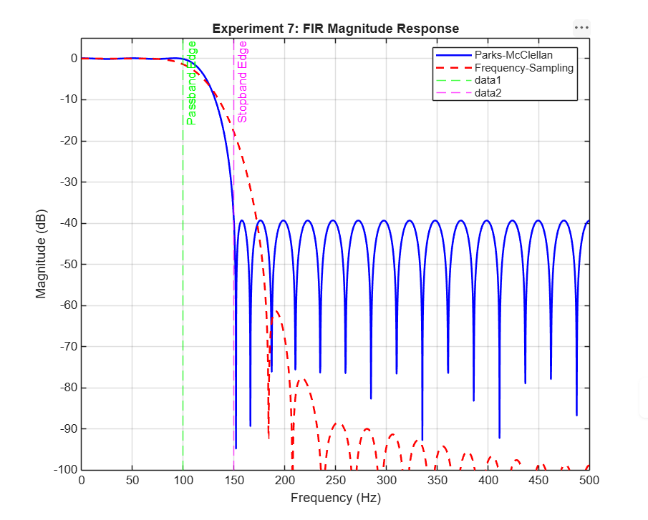
disp('Experiment 7 Completed Successfully.');
